Steps to call Google Annalistic API via SDK.

1. Go to <https://console.cloud.google.com/> and create your project

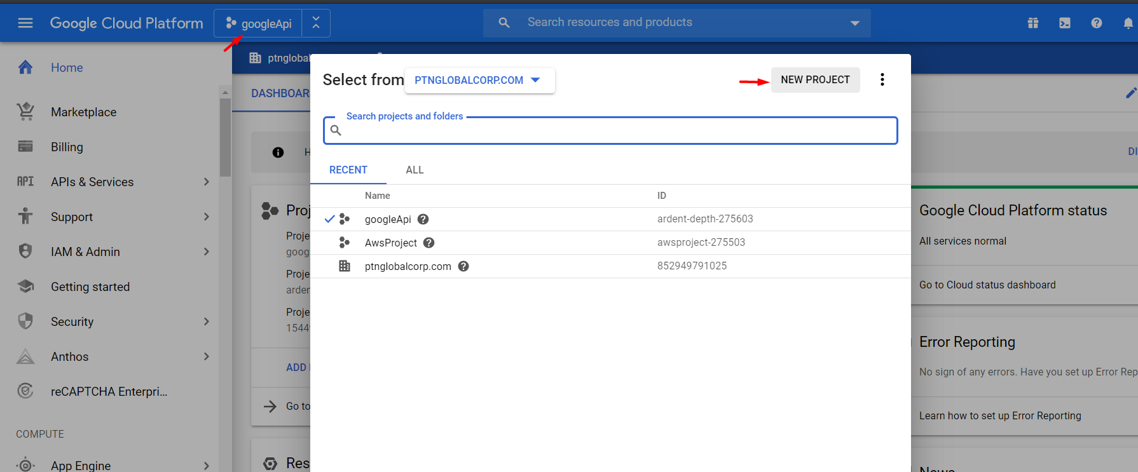

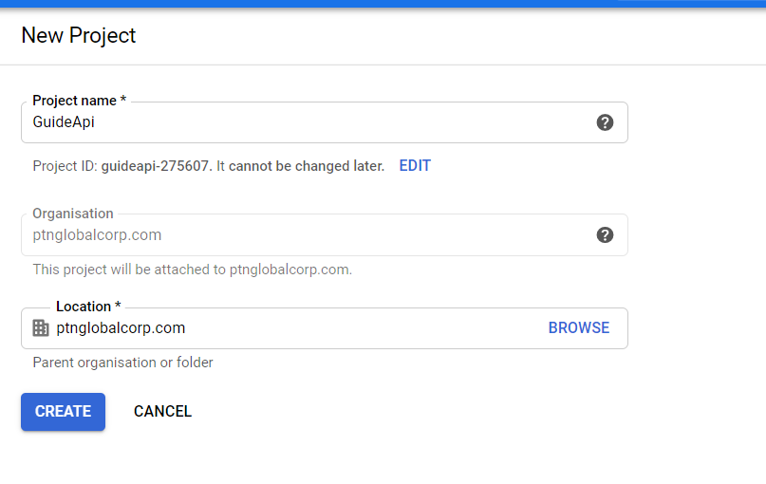

* **Enable Google Annalistic in your project**

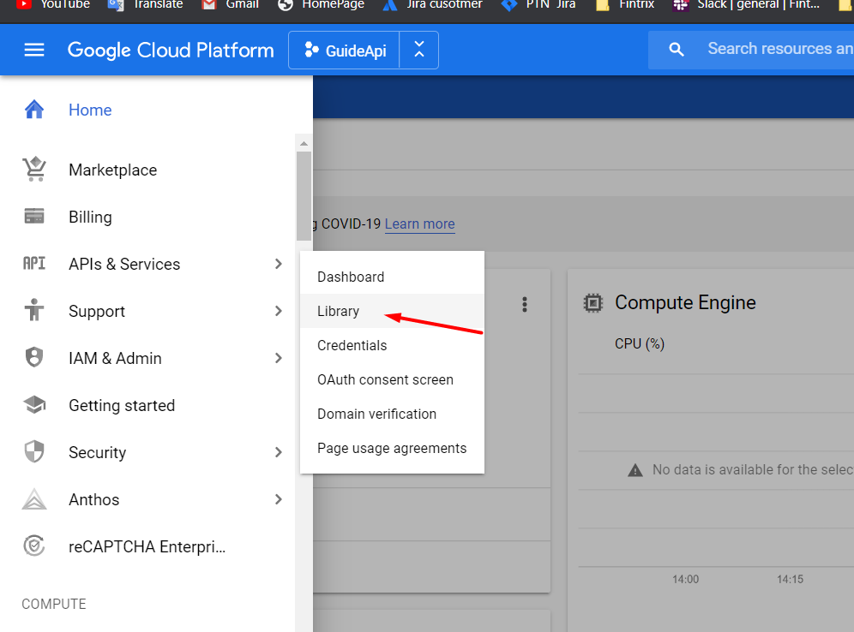

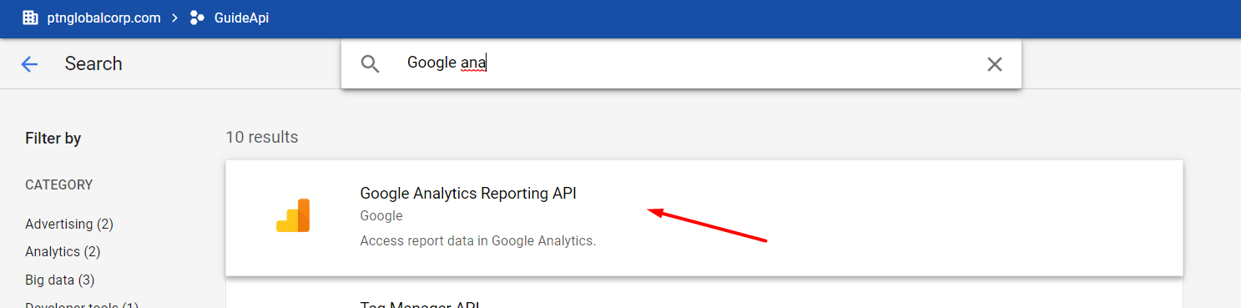

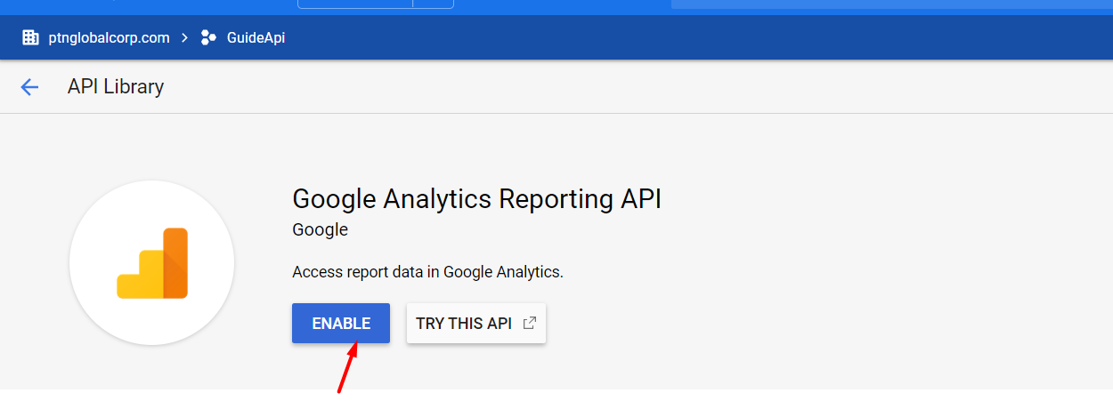

1. Open <https://console.developers.google.com/iam-admin/serviceaccounts> and select you Project
2. Choose Create Service Account

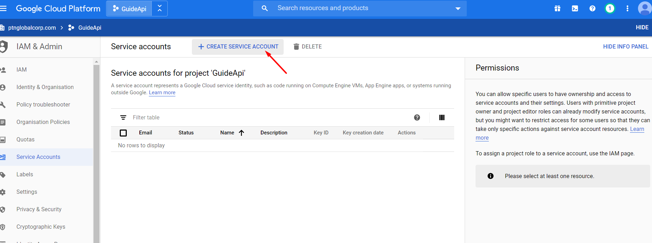

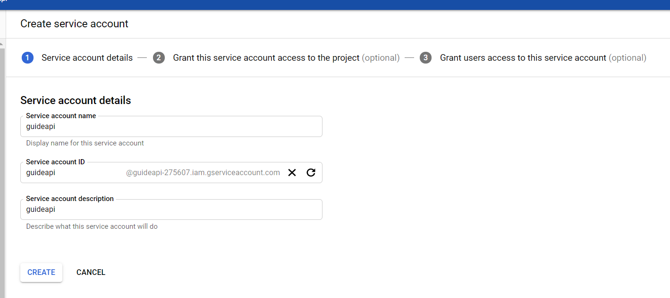

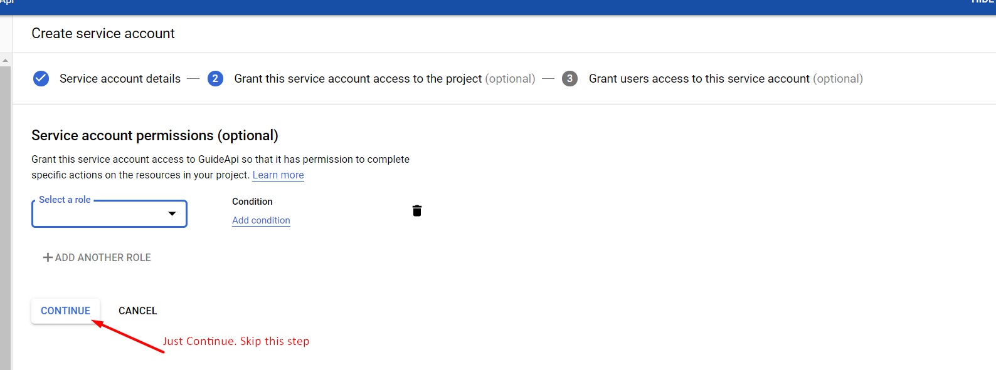

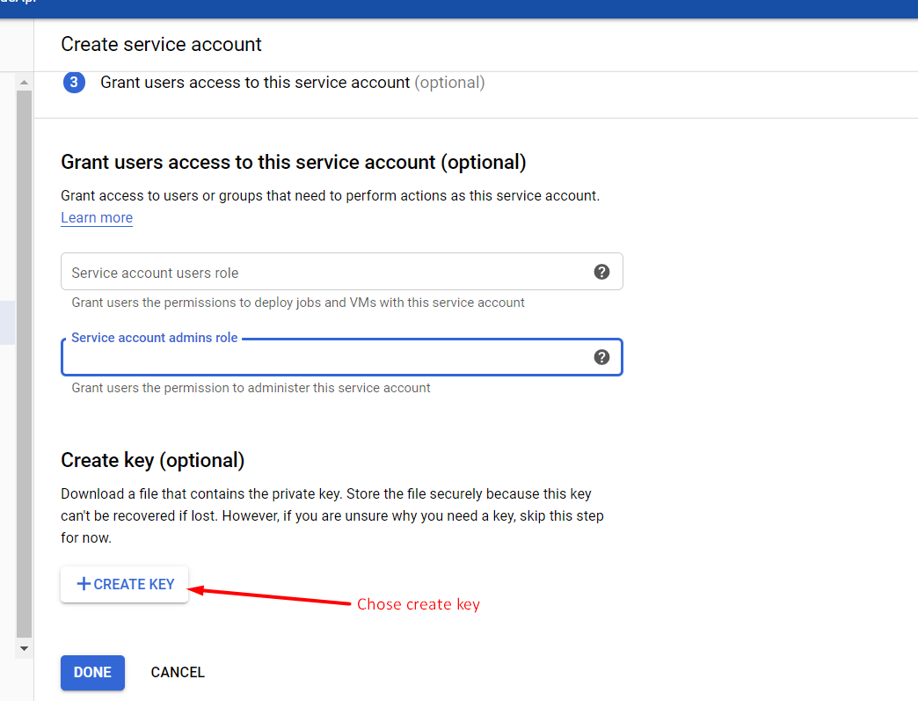

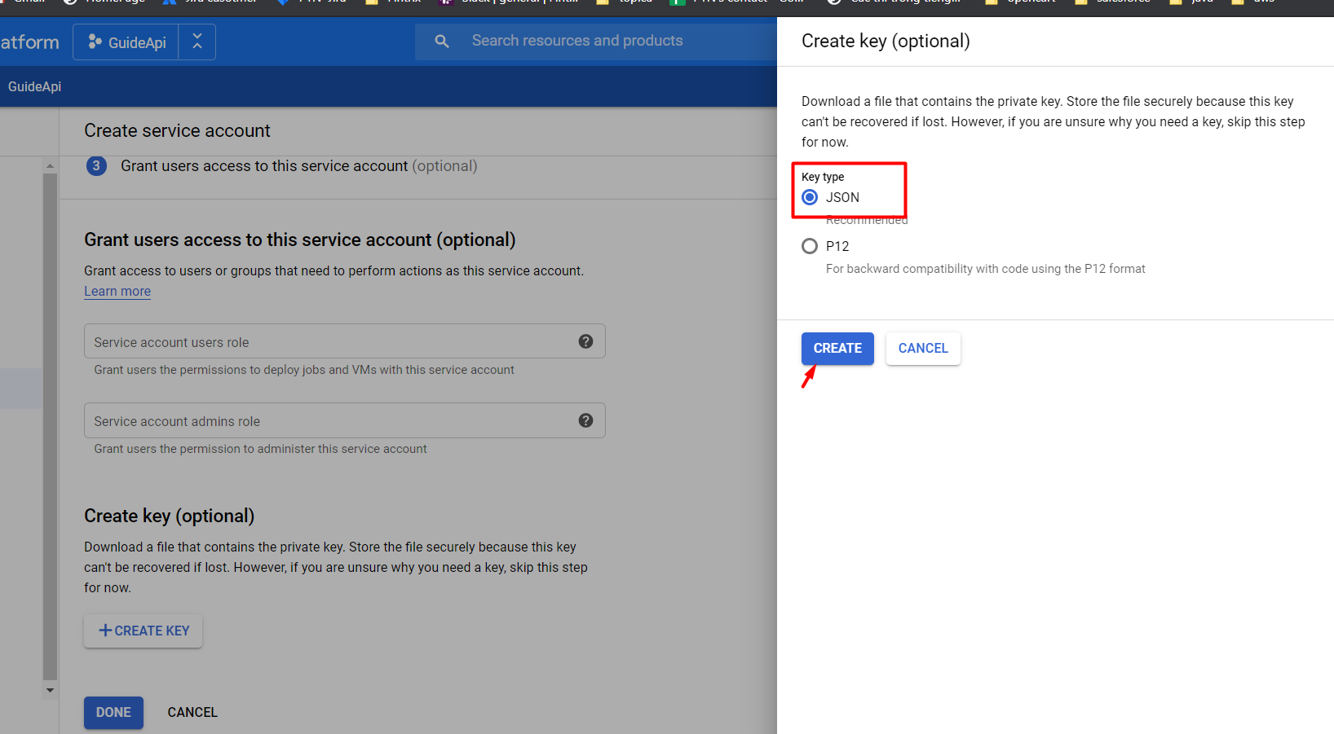

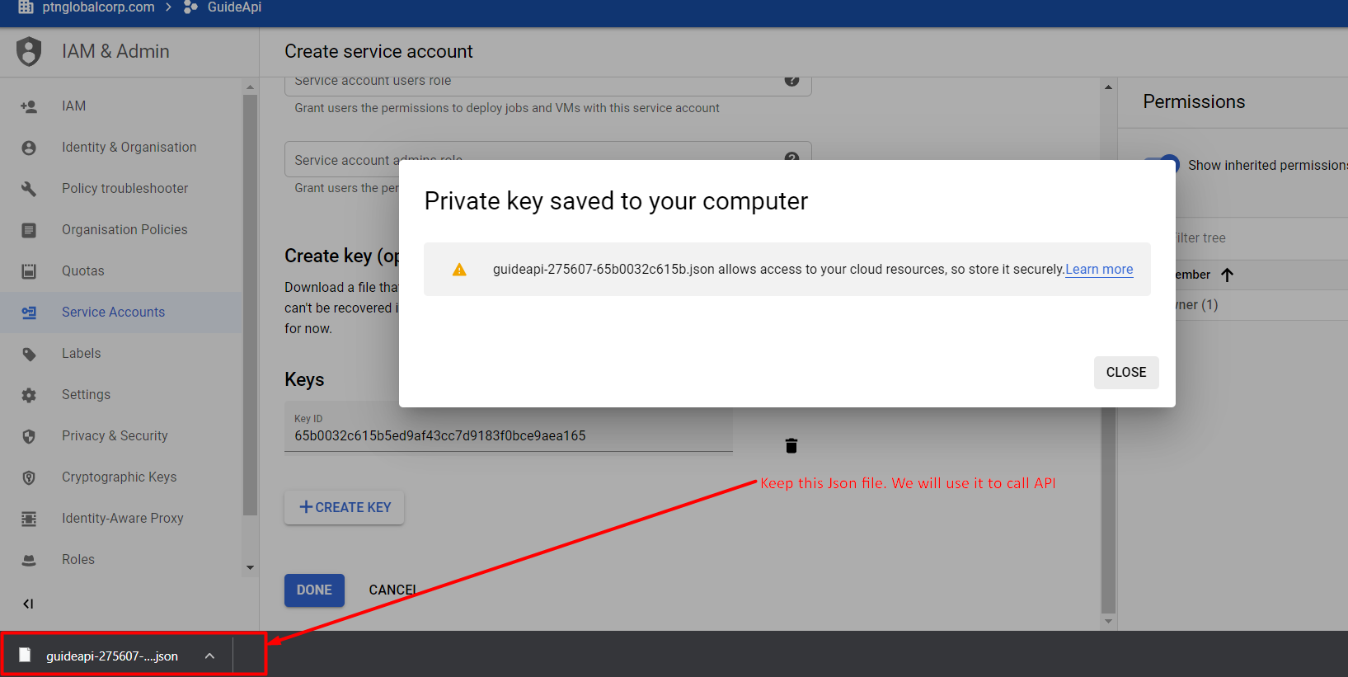

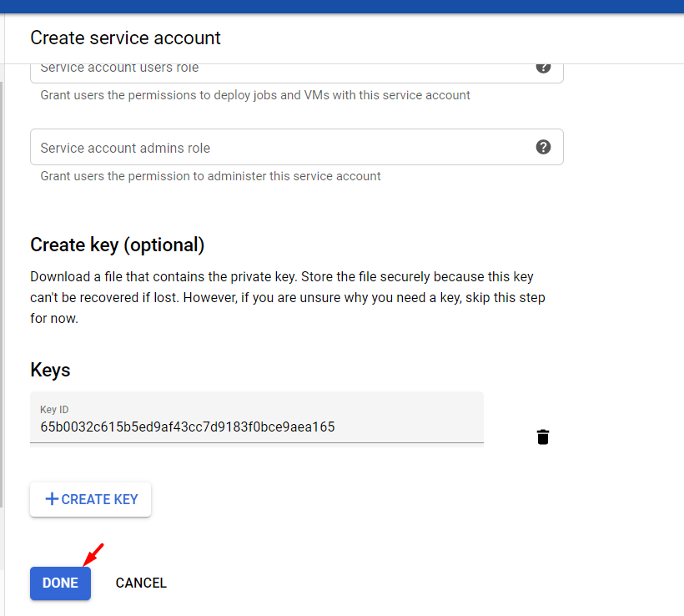

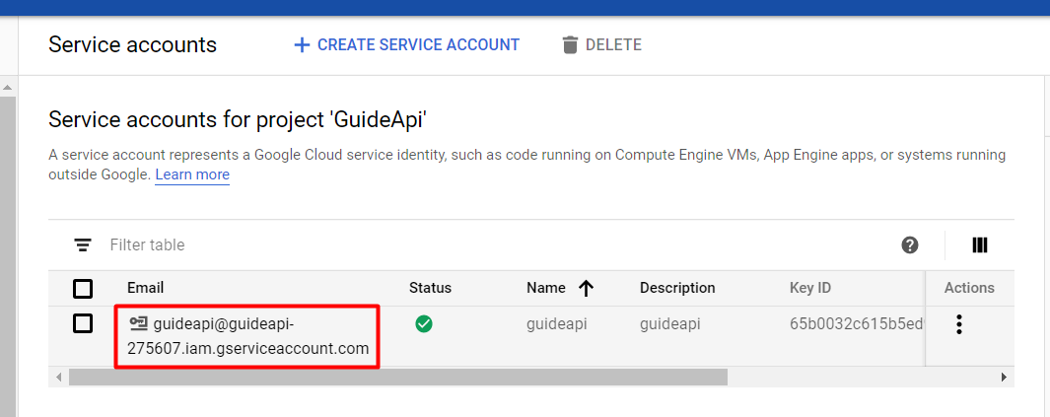

**We will use that email to register to Google Annalistic**

1. **Login to your Google Annalistic account to add an Email above**

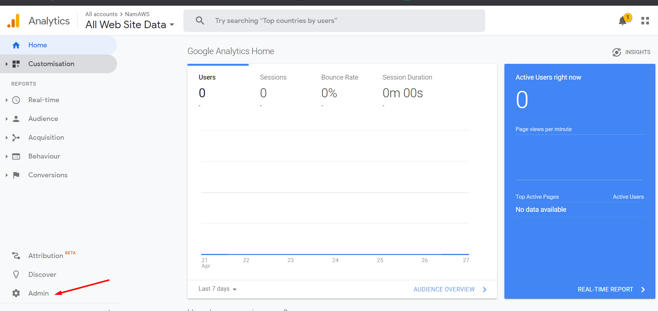

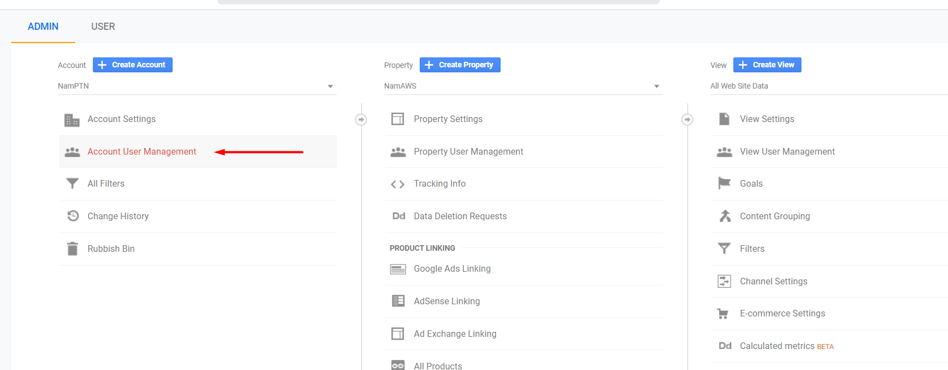

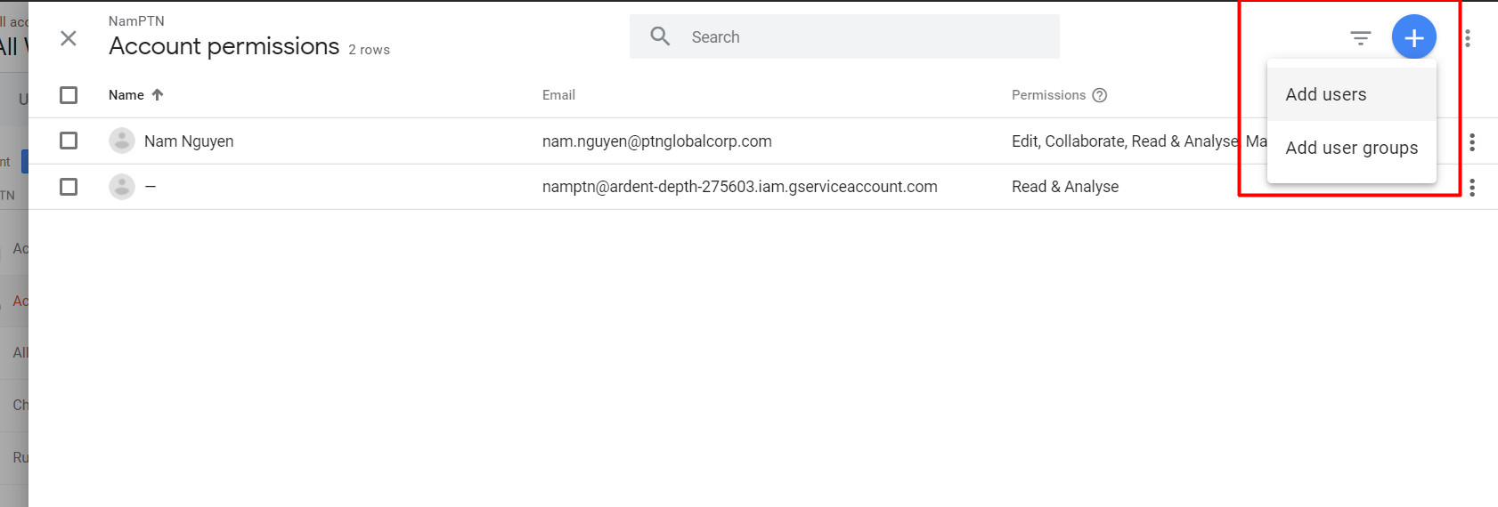

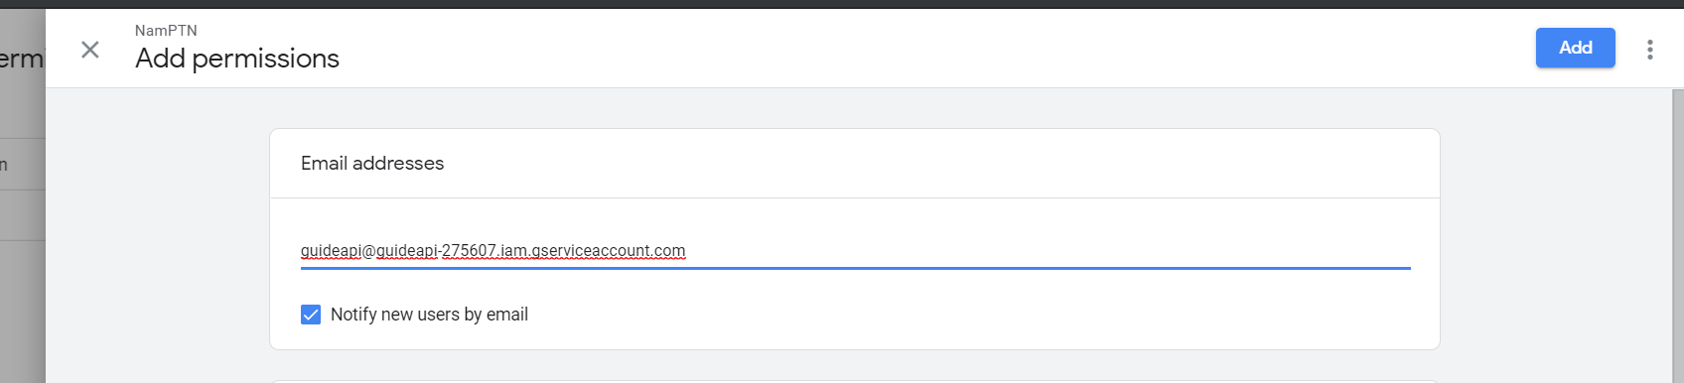

1. **Get my sample project and change some config as below**

<https://github.com/thanhnam192/googleAnalysticApiCall>

private static final String *KEY_FILE_LOCATION* = "<PATH TO Your Json key>";  
private static final String *VIEW_ID* = "<Your View ID in google Annalistic>";

**way to get VIEW_ID as below**

